**GUIDELINES FOR PREVENTION OF**

**POSTOPERATIVE NAUSEA AND VOMITING (PONV)**

Postoperative nausea and vomiting (PONV) is one of the leading postoperative complaints from patients and the leading cause of readmission to the hospital. Severe vomiting can be associated with dehydration, postoperative bleeding, pulmonary aspiration, and wound dehiscence.1

PONV occurs twice as frequently in children than in adults, increasing from 3 yrs of age until puberty, then decreasing to adult rates. Gender differences are not seen before puberty. The two most common emetogenic surgical procedures evaluated in children are strabismus repair and adenotonsillectomy.

Risk factors for PONV in children include the following:

1. Patient factors
   1. age ≥ 3 years
   2. history of Postoperative Vomiting (POV)/ PONV/motion sickness
   3. family history of postoperative vomiting (POV)/ PONV
   4. post pubertal female
   5. gastric dysmotility
   6. anxiety
   7. pain
2. Surgical factors
   1. surgery ≥ 30min
   2. adenotonsillectomy
   3. otoplasty
   4. strabismus surgery
   5. dental surgery
   6. intra abdominal surgery including laparoscopic
   7. genitourinary surgery
3. Anaesthetic factors
   1. volatile anaesthetics
   2. long acting opioids
   3. anticholinergic agents e.g. neostigmine

**PONV Risk Score for Children (Eberhart et al)**

| **Risk factors** | **Points** |
| --- | --- |
| Surgery ≥ 30min | 1 |
| Age ≥ 3 years | 1 |
| Strabismus surgery | 1 |
| History of postoperative vomiting or family history of PONV | 1 |

**Risk of postoperative vomiting associated with**

**number of risk factors for PONV**

| **Number of risk factors** | **Risk of postoperative vomiting** |
| --- | --- |
| 0 or 1 | 10% |
| 2 | 30% |
| 3 | 50% |
| 4 | 70% |

Do note that this score has been validated for other emetogenic surgeries as well.

Generally, strategies to prevent PONV in children include

1. Use of regional anaesthesia
2. Use of propofol for induction and maintenance of anaesthesia
3. Avoidance of nitrous oxide for more than 1 hour
4. Avoidance of volatile anaesthetic agents
5. Minimise perioperative opioid use with multimodal analgesia such as paracetamol, NSAIDS, clonidine or dexmedetomidine, ketamine or IV lignocaine given intraoperatively
6. Adequate hydration intraoperatively (30 vs 10 mL/kg lactated ringer’s more effective in PONV reduction) and consider allowing clear feeds up 1 hour before anaesthesia
7. Avoidance of neostigmine if feasible for reversal of neuromuscular blockade, using train of 4 as a guide on requirement for reversal and consider the use of sugammadex in patients at high risk of PONV
8. Prophylactic antiemetic therapy for children with any risk factor for PONV

**INTRA-OP PROPHYLAXIS**

Single drug (for low risk i.e. no risk factor or 1 risk factor)

* *IV ondansetron 0.1 -0.15mg/kg* (max 4 mg, only in children > 1 mth old, to be used with caution in cardiac patients with arrhythmias, particularly prolonged QT syndrome) for the following groups:
  + ≥ 3yrs
  + use of intraoperative opioids
  + middle ear surgery
  + surgeries ≥30 mins duration
  + side effects: headache/ prolongation of QT interval ( dose dependent and rarely significant at usual doses)

Double prophylaxis (for moderate risk i.e. 1-2 risk factors)

* *IV ondansetron 0.1- 0.15 mg/kg* (max 4 mg) AND
* *IV dexamethasone 0.1-0.15 mg/kg* (max 4mg) at the start of surgery IF NO CONTRAINDICATIONS and presence of at least 1 risk factor that includes any of the following:
  + - Strabismus surgery
    - Tonsillectomy ± Adenoidectomy
    - Middle ear surgery + opioid use
    - Previous history of PONV
  + side effects: hyperglycaemia, restlessness, headache, blurred vision
  + added advantage: can reduce pain
  + contraindication: Dexamethasone must be used with care in oncology patients since it can be part of the chemotherapy regimen for leukaemia and lymphoma patients and can result in tumour lysis syndrome, or affect the efficacy of CAR T-cell therapy.
  + If dexamethasone is contraindicated, then consider the use of oral aprepitant and ondansetron
* *Oral aprepitant 2 mg/kg (max 40 mg)* 1 hour before surgery.
  + a central NK1 receptor antagonist
  + Side effects: fatigue, headache, reduced appetite, constipation, dyspepsia, hiccups, flushing, diarrhoea,
  + be aware of CYP3A4 interactions such as with warfarin
  + limited use if the patient is actively vomiting
  + If the patient is unable to take capsules and requires a syrup form, the pharmacist will require 2-3 hours to prepare the compounded formulation. So please ensure that oral aprepitant is ordered early in SCM. Oral aprepitant will be compounded in aliquots of 20 mg/ml.
  + please order as a single order dose
  + oral aprepitant/ fosaprepitant should not be ordered until 72 hours after the last dose

For high risk patient (3 or more risk factors)

* double antiemetics
  + if dexamethasone and ondansetron are contraindicated, use oral aprepitant 1-3 mg/kg up to a maximum of 125mg (this is the maximum dose per day)
  + consider use of TIVA with propofol
* consider use of oral aprepitant if dexamethasone or ondansetron is contraindicated

**POST-OP PRESCRIPTION**

* IV ondansetron 0.15 mg/kg 8 hourly/prn for:
  + ALL SDA and inpatients at risk of PONV
  + ALL patients put on Acute Pain Service for PCA/NCA opioids and epidurals. (Order in the SCM along with Acute Pain Service orders)

TREATMENT for established vomiting (defined as vomiting ≥ 2X post-op)

If the patient has established vomiting despite PONV prophylactic antiemetic therapy, consider using an antiemetic from another class of drugs rather than repeat a dose of the antiemetic that has been administered within the past 6 hours.

Besides adverse psychological, metabolic and physiological effects, persistent vomiting is an unpleasant event that may lead to dehydration, electrolyte imbalances, pulmonary aspiration and surgical complications like wound dehiscence. Prompt management is therefore required and should focus on both pharmacological and non-pharmacological management.

Pharmacological management

* IV ondansetron 0.15mg/kg (max 8 mg)
  + If ondansetron has not been given
* IV dexamethasone 0.15 mg/kg (max 8 mg)
  + If only ondansetron has been given, and dexamethasone not given yet
  + Ensure no contra-indications eg. Hyperglycaemia, systemic sepsis, tumours
* If vomiting persists despite the above measures, call the consultant anaesthetist. The following may be considered with discretion:
  + IV Diphenhydramine 0.5-1 mg/kg ( max 25 mg)
  + side effects: sedation, urinary retention, dry mouth, blurred vision
  + not to use post tonsillectomy or other airway surgery
  + IV Metoclopramide 0.15-0.25mg/kg/dose 6h (maximum 0.5mg/kg/day or 30mg/ day)
  + contraindicated in infants
  + consider for bilious vomiting
  + do not continue if ineffective; efficacy uncertain
  + side effects: extrapyramidal side effects seen more commonly in children
  + Transdermal Scopolamine patch (Hyoscine 1 mg/72hr once), may have a role in safely ameliorating PONV in adolescents, not in younger paediatric patients.
  + Not FDA approved for less than 12 years old.
  + side effects: dry mouth, dizziness, blurred vision
  + IV Propofol subhypnotic dose infusion (as rescue in PACU only, ordered by consultant anaesthetist)
  + Oral aprepitant 2 mg/ kg (max 40 mg) may be considered although its efficacy for established vomiting is not well established.
  + to be ordered only by associate consultant or equivalent and above
  + dose not to be repeated before 72 hours of last dose of aprepitant/ iv fosaprepitant
  + Side effects: fatigue, headache, reduced appetite, constipation, dyspepsia, hiccups, flushing
  + IV fosaprepitant 3 mg/kg (max 150mg)
  + to be ordered only by associate consultant or equivalent and above
  + not to be given within 72 hours of oral aprepitant
  + Side effects: fatigue, headache, reduced appetite, constipation, dyspepsia, hiccups, flushing



Non-pharmacological intervention

1. hydration
2. acupressure point/ acustimulation: PC 6

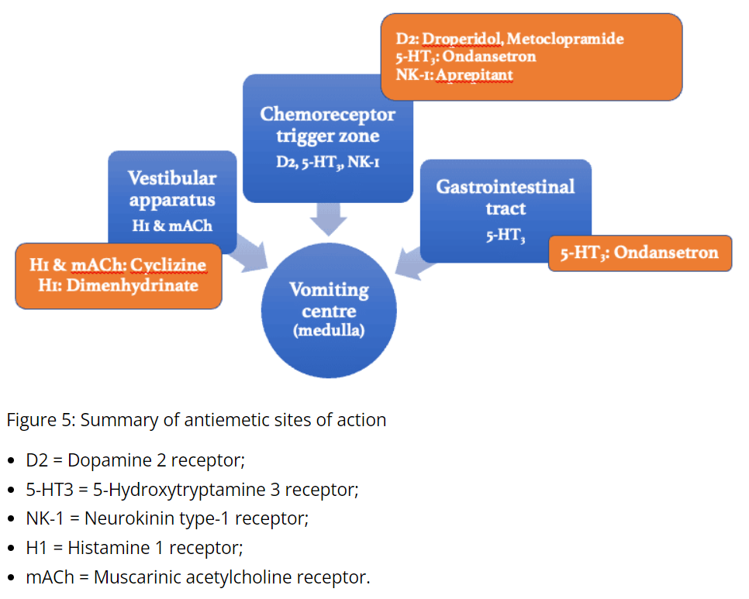

*References:*

1. *Management of postoperative nausea and vomiting in children. Paediatr Drugs. 2007;9(1):47-69.*
2. *Guidelines on the Prevention of Postoperative Vomiting in Children. APA guidelines 2009.*
3. *The development and validation of a risk score to predict the probability of postoperative vomiting in pediatric patients. Anesth Analg 2004;99:1630–7*
4. *A prospective evaluation of the POVOC score for prediction of postoperative vomiting in children Anesth Analg 2007; 105:1592-7*
5. *Consensus guidelines for the management of postoperative nausea and vomiting. Anesth Analg. 2014 Jan;118 (1):85-113.*
6. [*Paediatric Postoperative Vomiting : Virtual Library*](https://resources.wfsahq.org/atotw/paediatric-postoperative-vomiting/)
7. [*https://www.rch.org.au/anaes/pain_management/*](https://www.rch.org.au/anaes/pain_management/)
8. *Gan, TJ, Belani, KG, Bergese, S et al.Fourth Consensus Guidelines for the Management of Postoperative Nausea and Vomiting. Anesthesia & Analgesia 131(2):p 411-448, August 2020*
9. *Elvir-Lazo OL, White PF, Yumul R, Cruz Eng H. Management strategies for the treatment and prevention of postoperative/postdischarge nausea and vomiting: an updated review. F1000Res. 2020 Aug 13;9:F1000 Faculty Rev-983. doi: 10.12688/f1000research.21832.1.*
10. *Kovac AL. Postoperative Nausea and Vomiting in Pediatric Patients. Paediatr Drugs. 2021 Jan;23(1):11-37. doi: 10.1007/s40272-020-00424-0. Epub 2020 Oct 27.*
11. *Martin S, Baines D, Holtby H, Carr AS. Guidelines on the Prevention of Post-operative Vomiting in Children. The Association of Paediatric Anaesthetists of Great Britain and Ireland.*